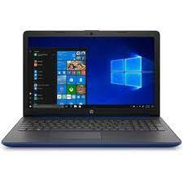

HP 15-DA2021TX

* CORE I5 10TH GEN
* 4GBRAM DDR4
* GEFORCE MX110 2GB
* 15.6" HD 1TB HDD
* **Rs, 99,999**